NEW Online Time Clock Information for Users

Link for Employee Self Service:
https://login.tmsconnexion.com/millardpublicschool?uri=millardpublicschool
Login Screen
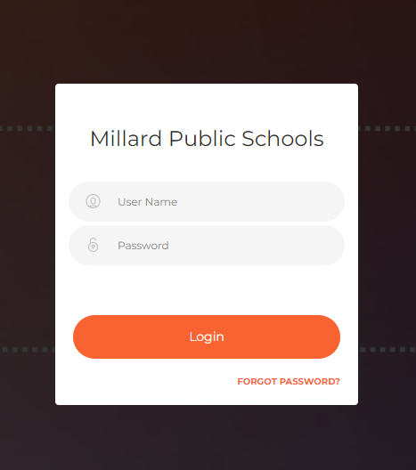

User Name (formerly Badge/ID)
Your User Name is your badge number.
Password (formerly PIN)
Your Password is your Employee ID with leading zeros. Passwords are required to be at least 6 characters. So, your Password will be your Employee ID, front filled with zeros. Please see the following examples:
Employee ID – 792 Password – 000792
Employee ID – 7141 Password – 007141
Employee ID – 21222 Password – 021222
If your password has been reset, your password defaults to FIRST NAME+LAST NAME+EMPLOYEE ID (no spaces and all upper case).
Example – Name: Joe Smiley; Employee ID#12345 – Reset password would be: JOESMILEY12345 - Next, you will be prompted to establish your own password.
Once logged in you will be at the dashboard.
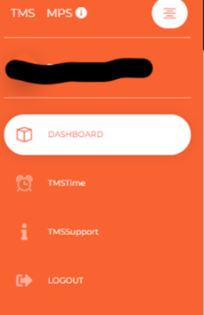
To punch, click on TMSTime on the left-hand side, then click the Punch button.
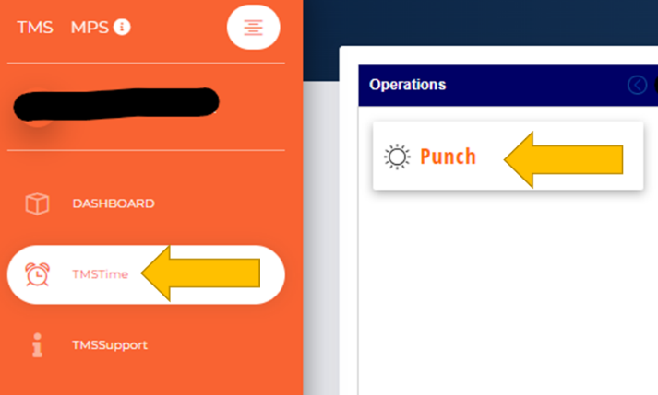
To change to the Time Card View, select Time Card.
